Building a Detection Lab
Part 2: Simulating and Hunting an Attack Chain in Splunk
cyberwithalish
SOC Analyst Home Lab Series
Recon and Credential Access to Post-Compromise Discovery, mapped to MITRE ATT&CK

1. Overview and objective
Part 1 of this series stood up a working detection lab and confirmed telemetry was flowing into Splunk. Part 2 puts that lab to work. The goal is to run a full, realistic attack chain against the victim host, then hunt each stage in Splunk and map every detection to a MITRE ATT&CK technique.
The chain follows the way a real intrusion unfolds: reconnaissance, then credential access, then post-compromise discovery and execution. Detecting a chain rather than a single tool is what turns a lab exercise into something that reads like analyst work.

Lab environment
- Kali Linux: the attacker host.
- Windows 11 (victim): running Sysmon with the SwiftOnSecurity config and the Splunk Universal Forwarder.
- Ubuntu Server: running Splunk Enterprise as the SIEM.
- Networking: all three virtual machines on VMware using NAT.
Sourcetypes in scope: WinEventLog:Microsoft-Windows-Sysmon/Operational, WinEventLog:Security, and WinEventLog:System.

2. Pre-flight checks
Two things matter before any attack traffic is generated. First, the virtual machine clocks have to agree, or Splunk cannot line events up in time. Second, telemetry has to be confirmed live so that an empty search later means the attack was quiet, not that the pipeline was broken.
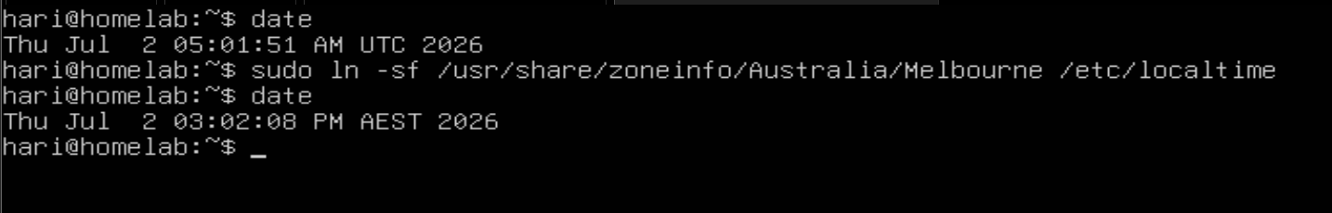
Figure 1: Ubuntu time synchronisation
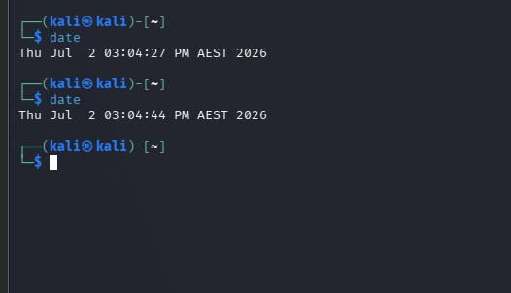
Figure 2: Kali and Windows clocks confirmed in sync
A single logon event was pulled to confirm the Security channel was reaching Splunk:
index=* sourcetype="WinEventLog:Security" EventCode=4624 | head 1
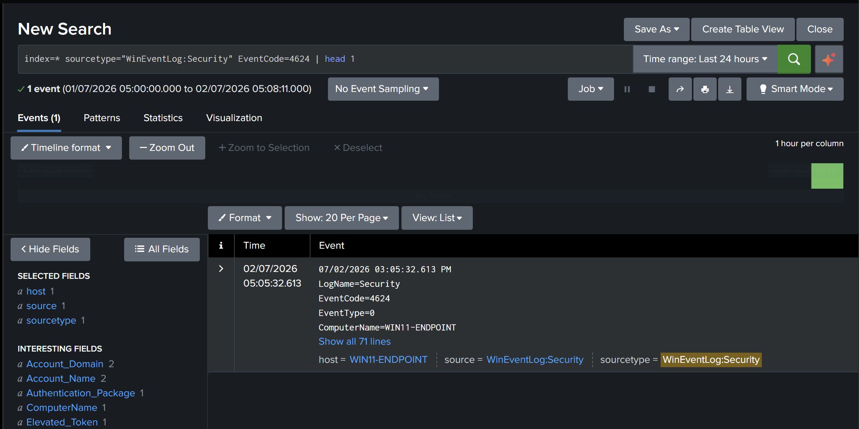
Figure 3: A logon event confirms the Security feed is live
Tip for next time: running index=* | stats count by sourcetype over the last fifteen minutes proves all three feeds at once, which is a faster and more complete health check than a single event.

3. Phase A: Baseline normal activity
Before hunting anything malicious, it helps to know what normal looks like. Ordinary activity was generated on the victim: a web browser was opened, a YouTube video was watched, a file was written in Notepad, and a few commands were run in the terminal. That gives the later attack traffic something ordinary to stand out against.
Logon volume by account and logon type:
index=* sourcetype="WinEventLog:Security" EventCode IN (4624,4625)
| rex "Account Name:\s+(?<acct>\S+)"
| stats count by EventCode, acct, Logon_Type
| sort - count
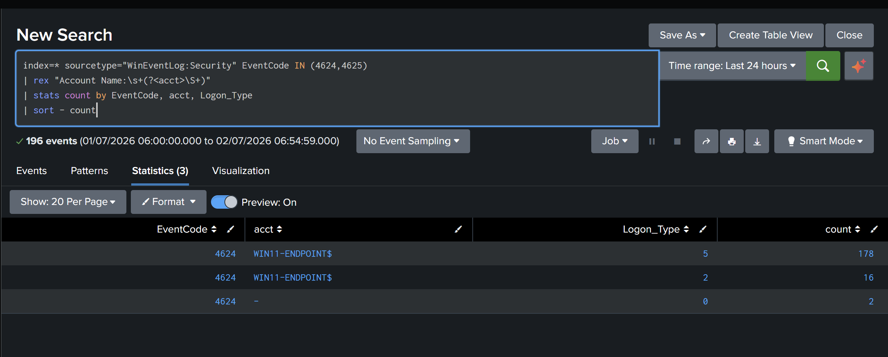
Figure 4: Baseline logon volume by account and logon type
Top process creations. This is where the SwiftOnSecurity Sysmon config earns its keep, since it records full process-creation detail:
index=* sourcetype="WinEventLog:Microsoft-Windows-Sysmon/Operational" EventCode=1
| stats count by Image | sort - count | head 20
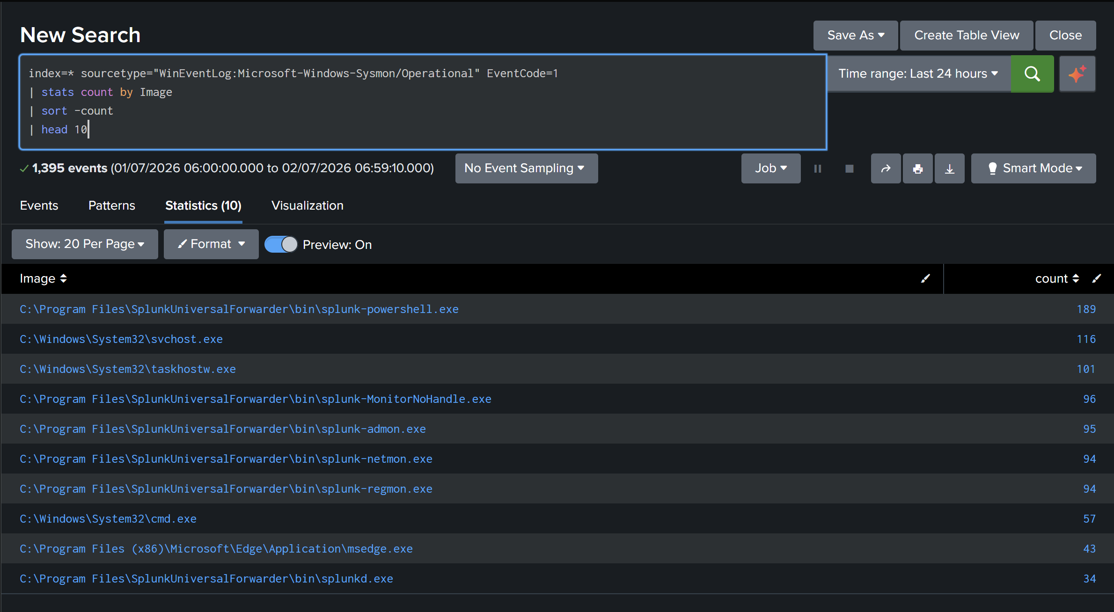
Figure 5: Top process creations on the baseline host
Outbound network connections seen during normal use:
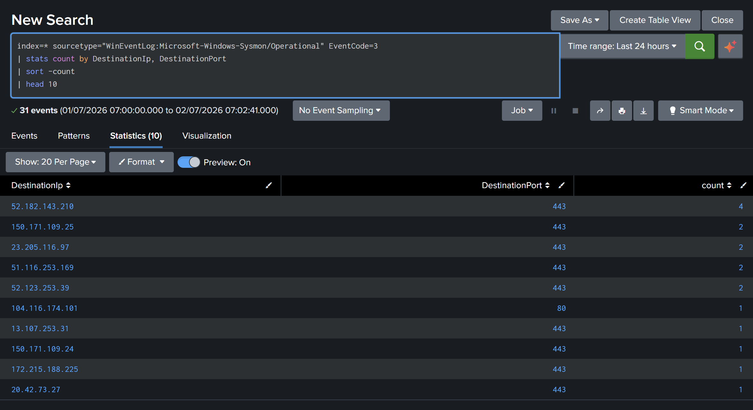
Figure 6: Baseline outbound network traffic

4. Phase B: Reconnaissance with Nmap
The first attack stage is discovery. From Kali, the victim was scanned to find live hosts and open services.
nmap -sn 192.168.72.131
nmap -sS -p- 192.168.72.131
nmap -sV -sC -p 135,139,445,3389 192.168.72.131
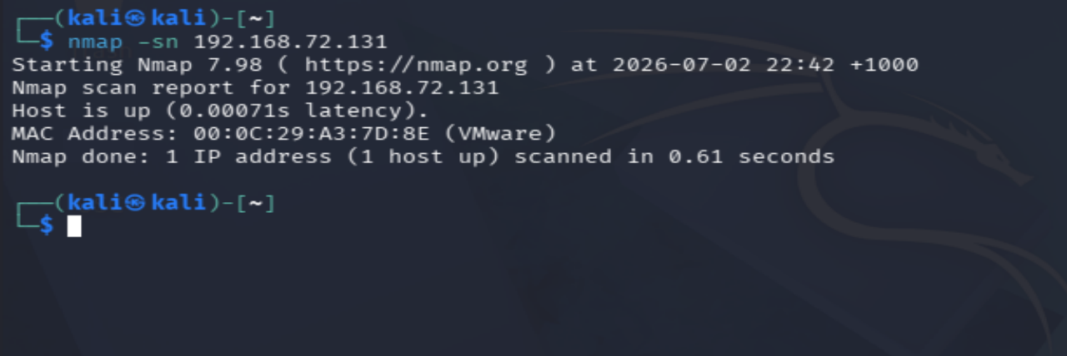
Figure 7: Nmap host discovery
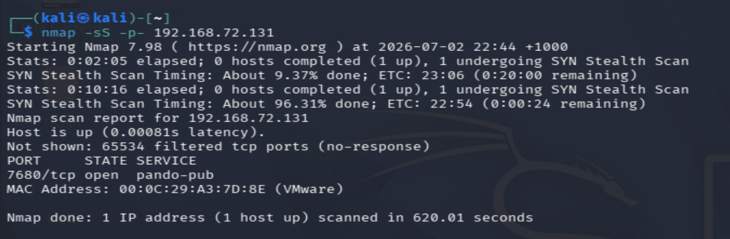
Figure 8: Full TCP port scan, port 7680 open
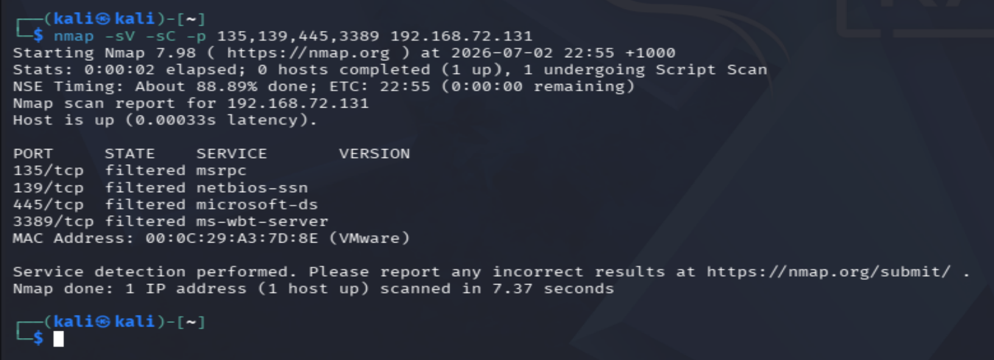
Figure 9: Targeted service scan on selected ports
The port that showed up, 7680, is pando-pub, which is the Windows Delivery Optimisation service tied to OneDrive and Windows Update. Searching Splunk over the last sixty minutes returned only OneDrive-related events, and a note worth recording: the victim could not be pinged from Kali, most likely because Windows Defender Firewall was dropping ICMP.
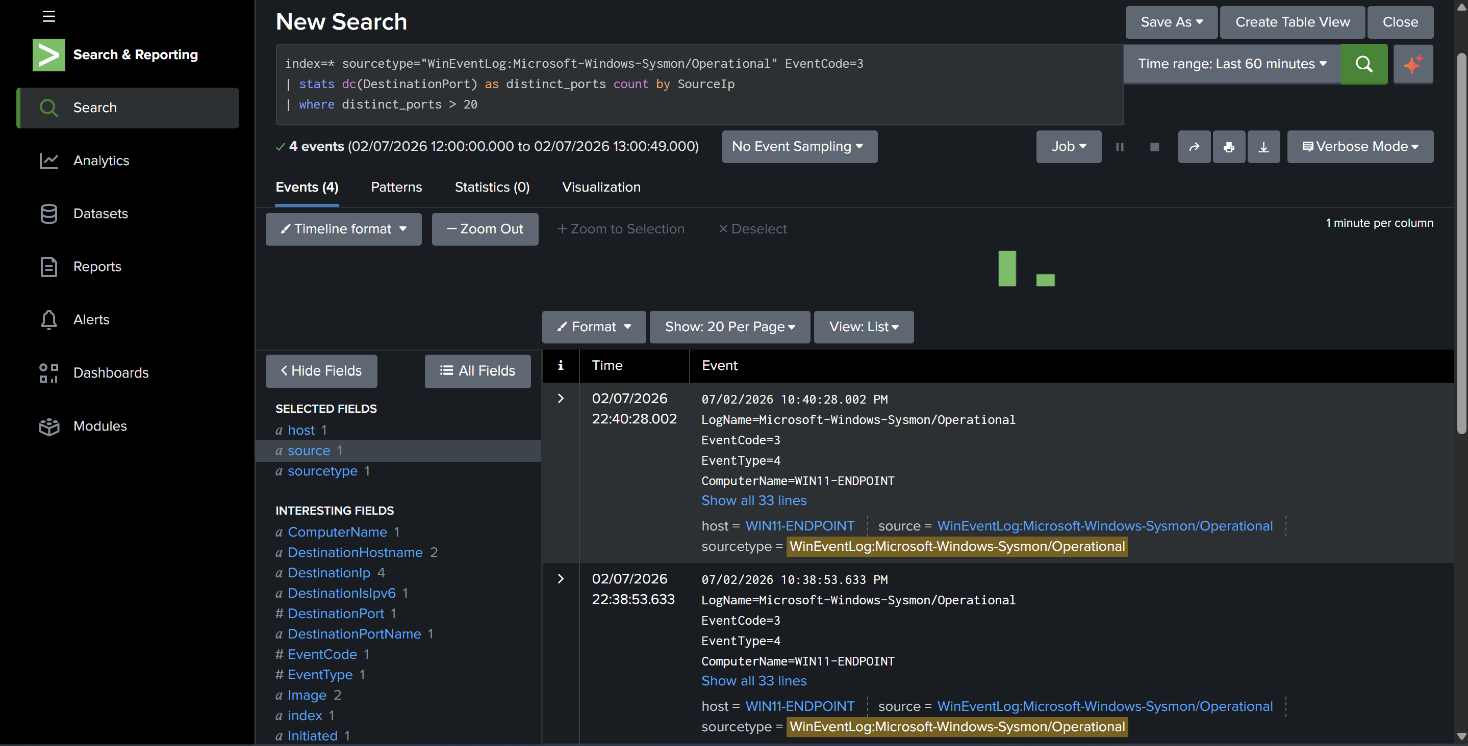
Figure 10: Splunk search for scan-related activity
An honest limitation worth stating plainly. Host-based Sysmon is weak at catching port scans. Closed-port probes often generate no host event at all, and the SwiftOnSecurity config logs network connections selectively. Where the scan did leave a trace was in the Windows Filtering Platform events, 5156 and 5157, which record allowed and blocked connections when firewall auditing is on. The takeaway is that scan detection really belongs on a network sensor rather than an endpoint, which is a good argument for adding a network monitoring or honeypot project later.
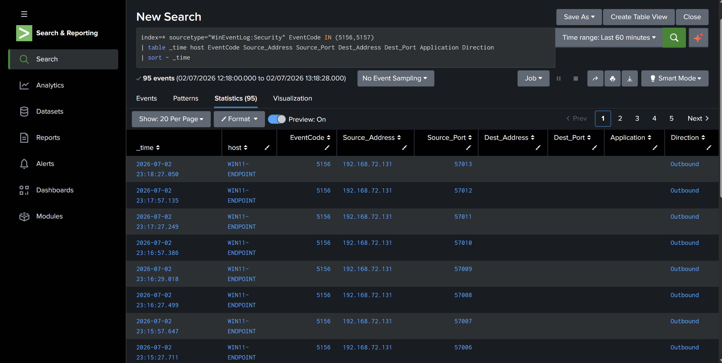
Figure 11: Windows Filtering Platform events 5156 and 5157

5. Phase C: Brute force
The second stage is credential access. A throwaway local account was created on the victim, and a small wordlist containing the real password was built on Kali so that at most one attempt would succeed.
net user labuser <password> /add
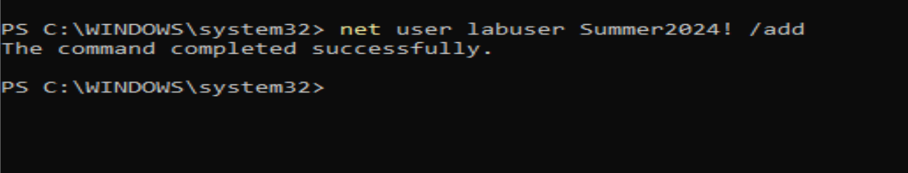
Figure 12: Test account created on the victim
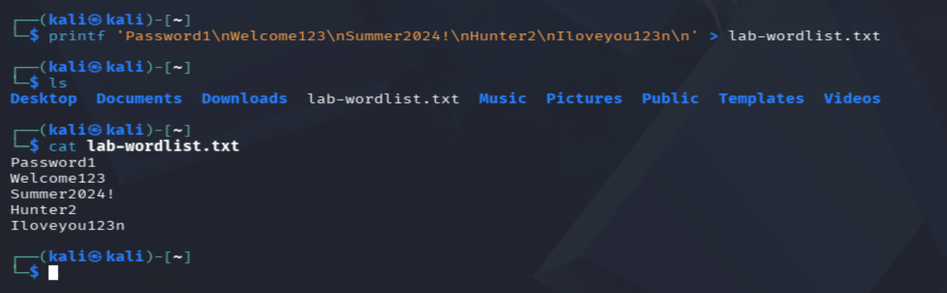
Figure 13: Wordlist created on Kali
Two brute-force paths were attempted. NetExec was used against SMB, and hydra was used against RDP.
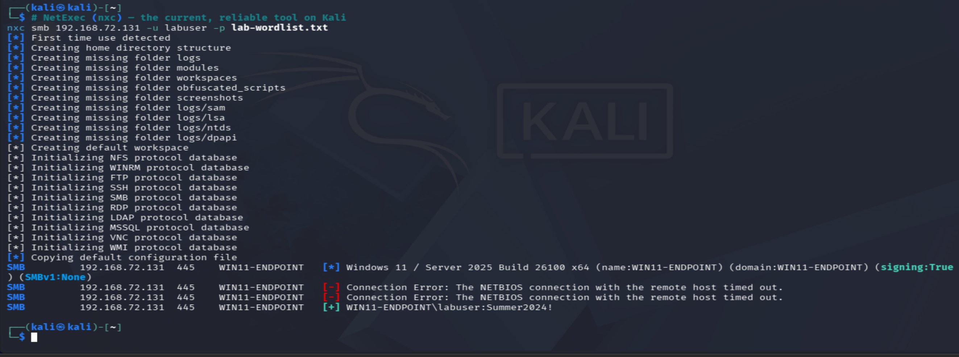
Figure 14: SMB brute force with NetExec
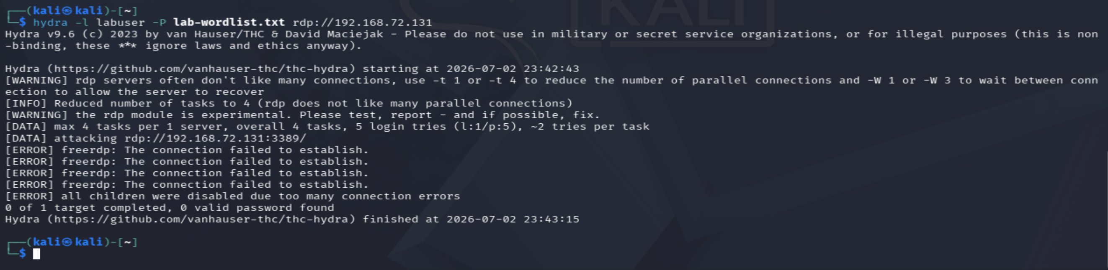
Figure 15: RDP brute force with hydra, which failed
What actually happened. The SMB brute force succeeded. NetExec validated the account, shown by the green success line reading labuser:Summer2024!. Because the account is not a local administrator, there was no code execution, only confirmed valid credentials. The RDP attempt failed even with the correct password, because the victim is Windows 11 Home, which does not include an RDP server for hydra to authenticate against.
The failed attempts that preceded the success were captured as EventCode 4625:
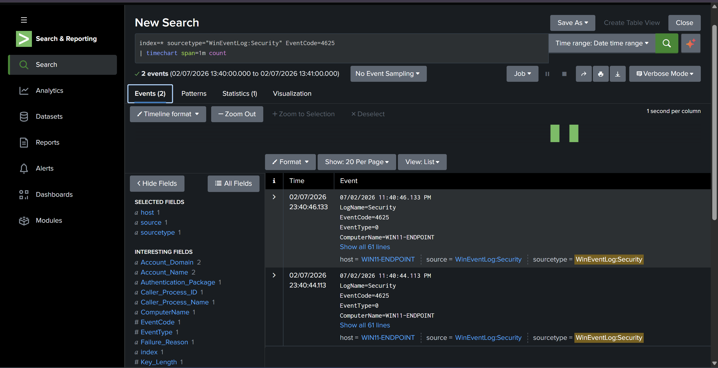
Figure 16: Failed logon events, EventCode 4625
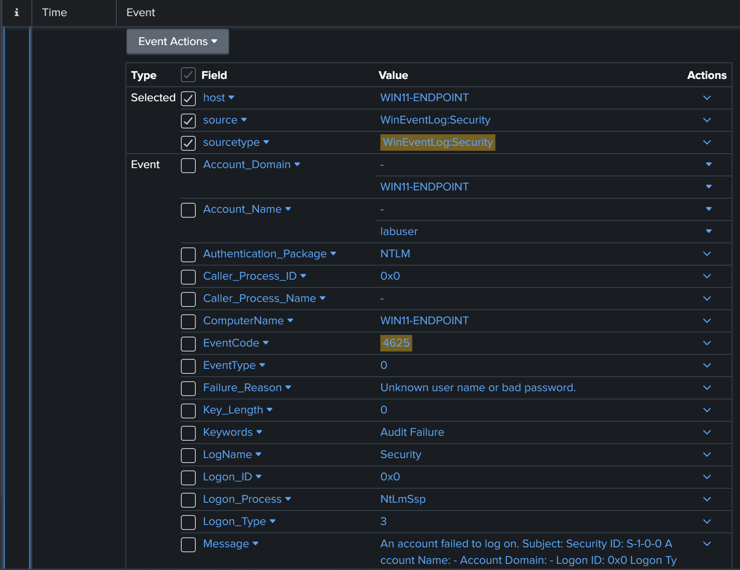
Figure 17: Failed logon event detail
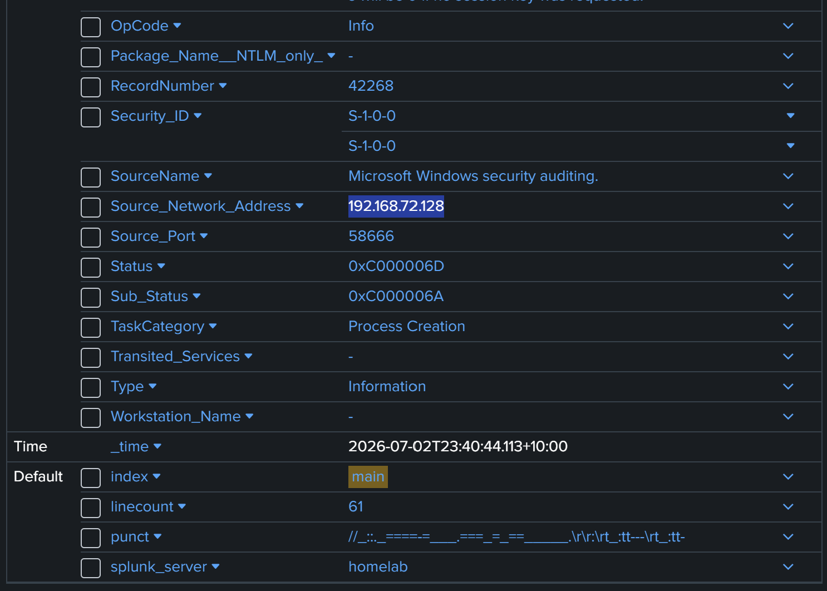
Figure 18: Source details for the failed logon
The hunt for the failed attempts and their source:
index=* sourcetype="WinEventLog:Security" EventCode=4625
| rex "Source Network Address:\s+(?<src_ip>\S+)"
| rex "Account Name:\s+(?<target_acct>\S+)"
| stats count by src_ip, target_acct | sort - count
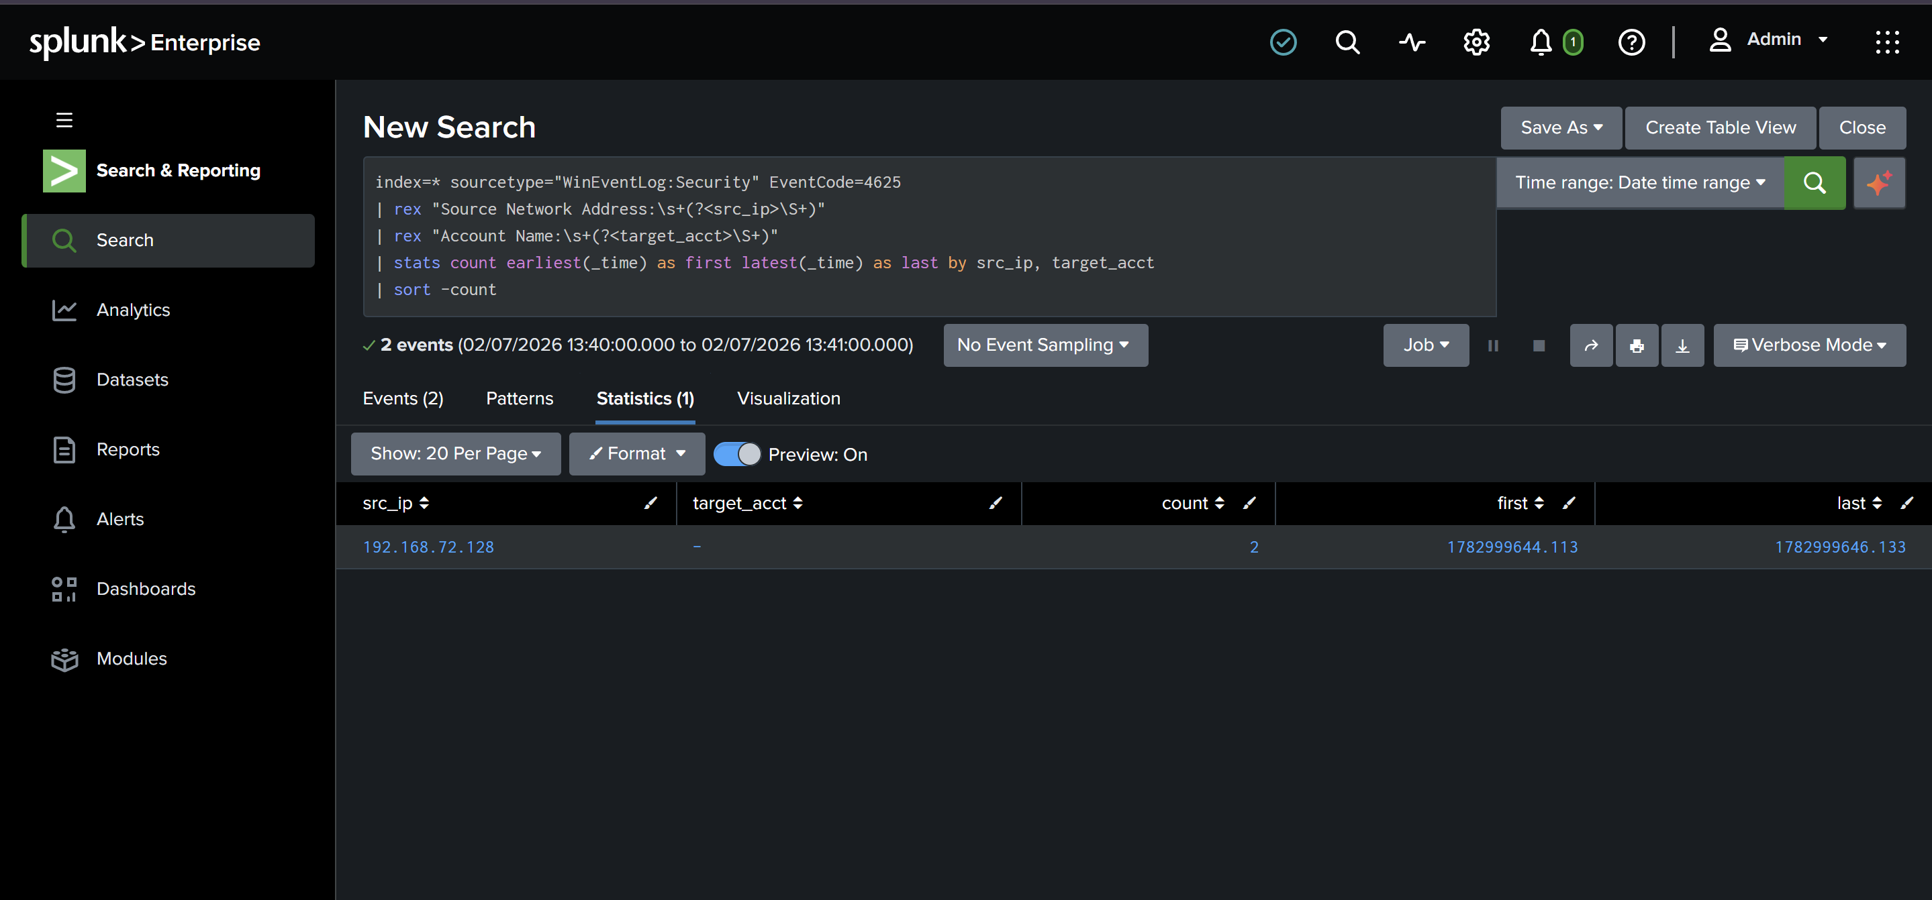
Figure 19: Failed logon attempts located in Splunk
Hunting for the successful logon from the attacker returned two events, both from the Kali host at 192.168.72.128:
index=* sourcetype="WinEventLog:Security" EventCode=4624 Logon_Type=3
| rex "Source Network Address:\s+(?<src_ip>\S+)"
| search src_ip="192.168.72.128"
| table _time, Account_Name, Logon_Type, src_ip
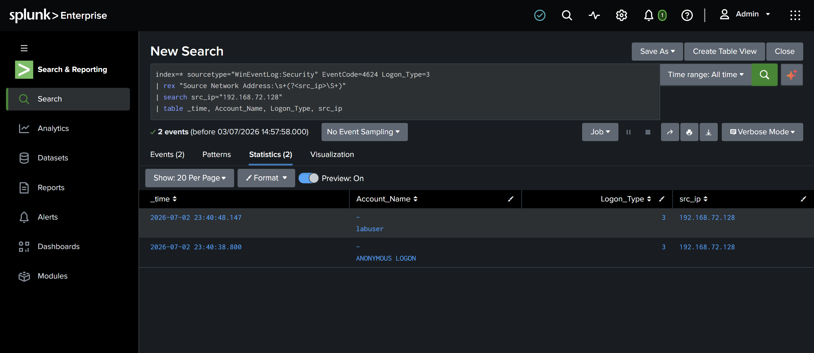
Figure 20: The successful network logon from the attacker, confirming the compromise
Analyst takeaway. The two events tell the whole story. One is the labuser account logging on successfully over the network, which is the compromise itself. The other is an ANONYMOUS LOGON from the same source, which is NetExec enumerating the SMB service before it authenticated. Placed next to the failed attempts, the sequence is the classic brute-force signature: several failures from one source, then a successful logon from that same source.

6. Phase D: Post-compromise discovery and execution
The final stage assumes an attacker already has a foothold and is enumerating the host. This is the strongest part of the lab, because full process-creation logging is exactly what the Sysmon config captures best, and these detections are reliable.
A realistic discovery sequence was run on the victim:
whoami /priv
net user
net localgroup administrators
ipconfig /all
systeminfo
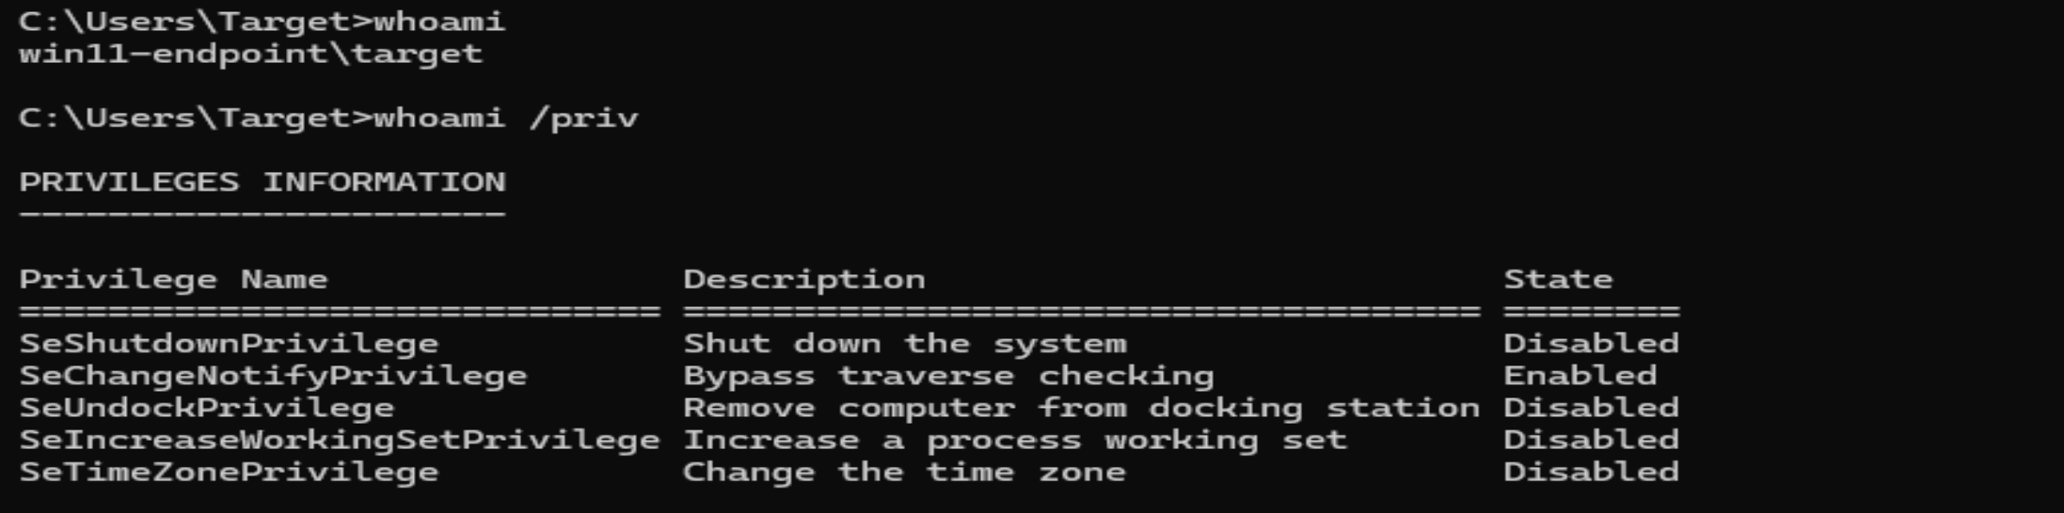
Figure 21: whoami and privilege enumeration
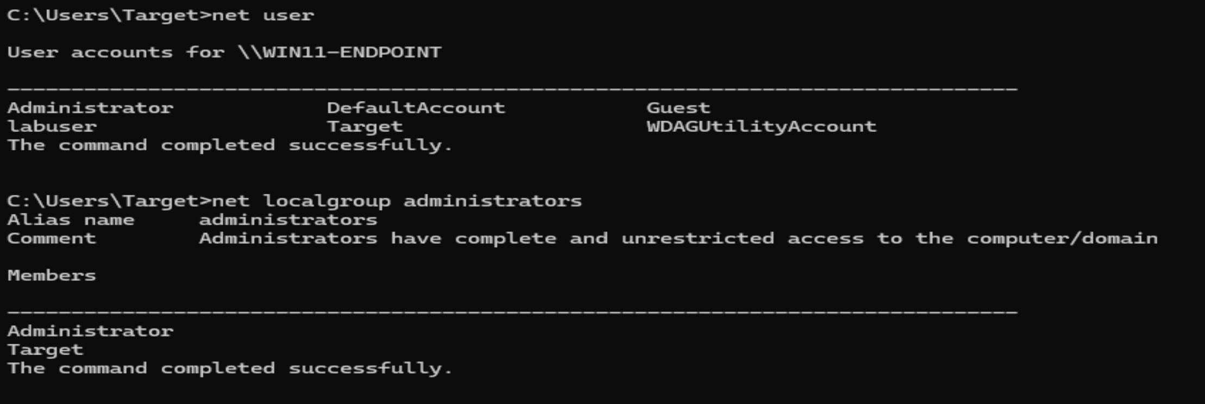
Figure 22: Local user and administrator group enumeration
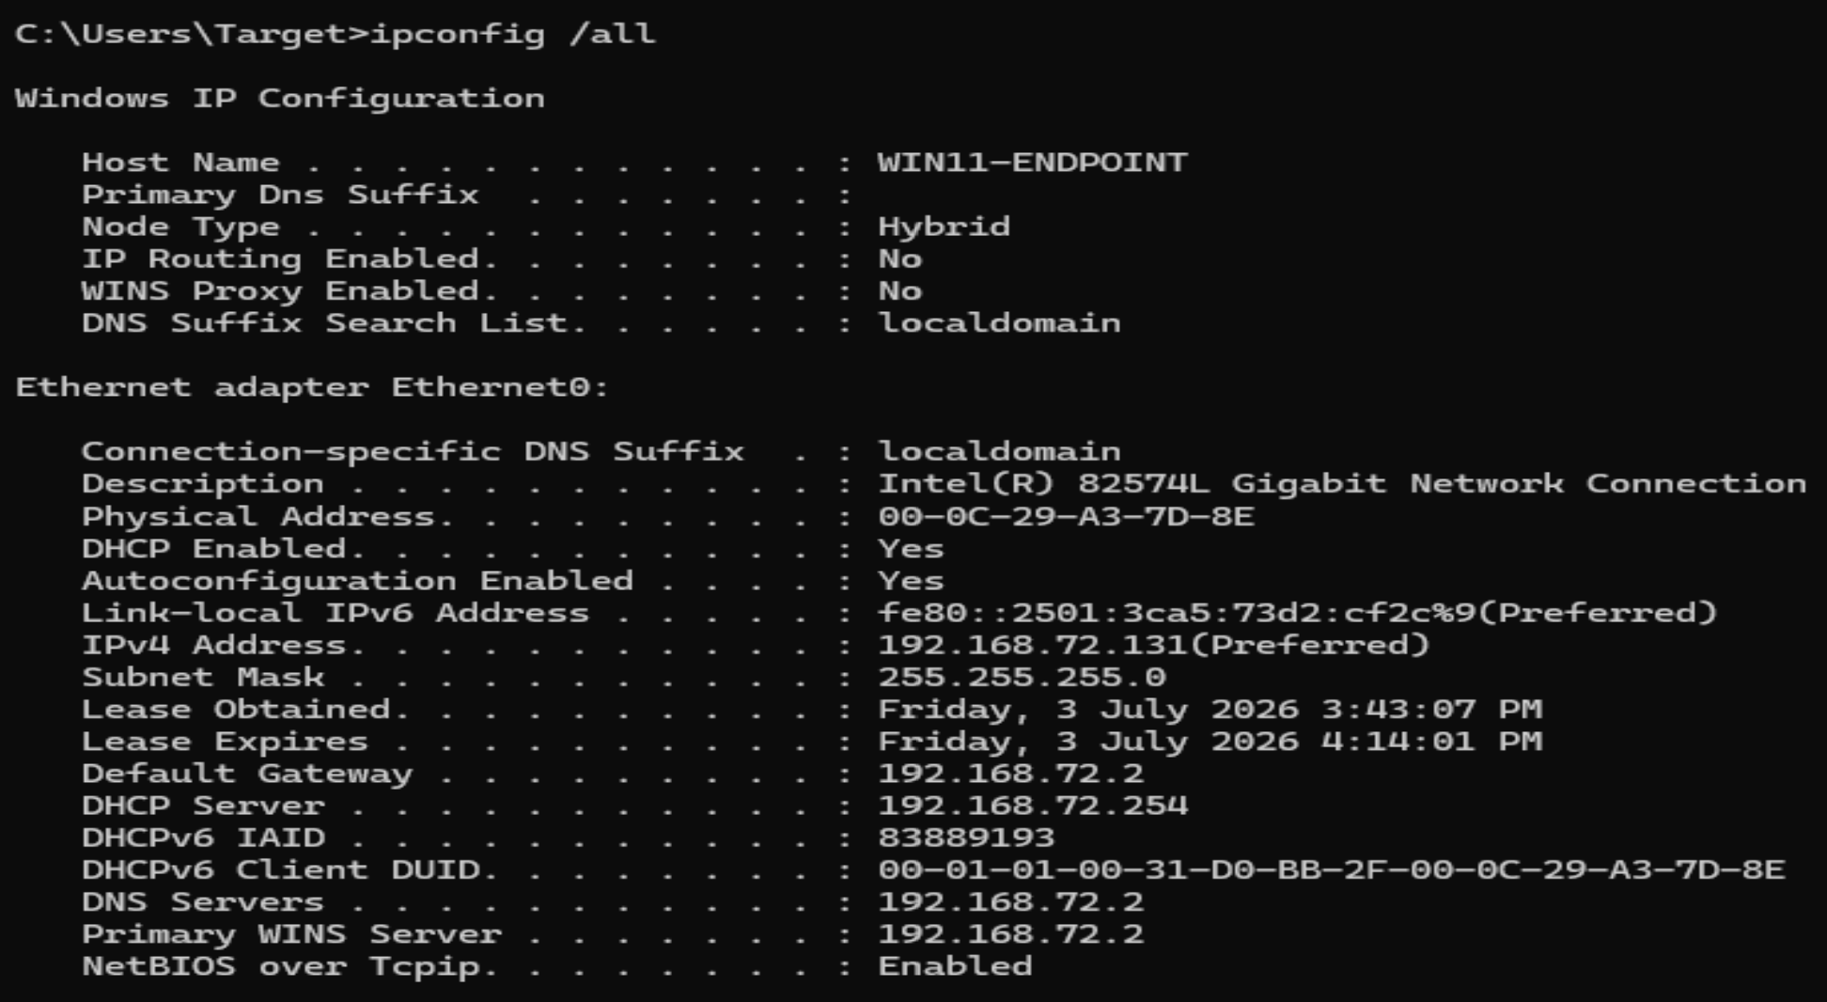
Figure 23: Network configuration discovery
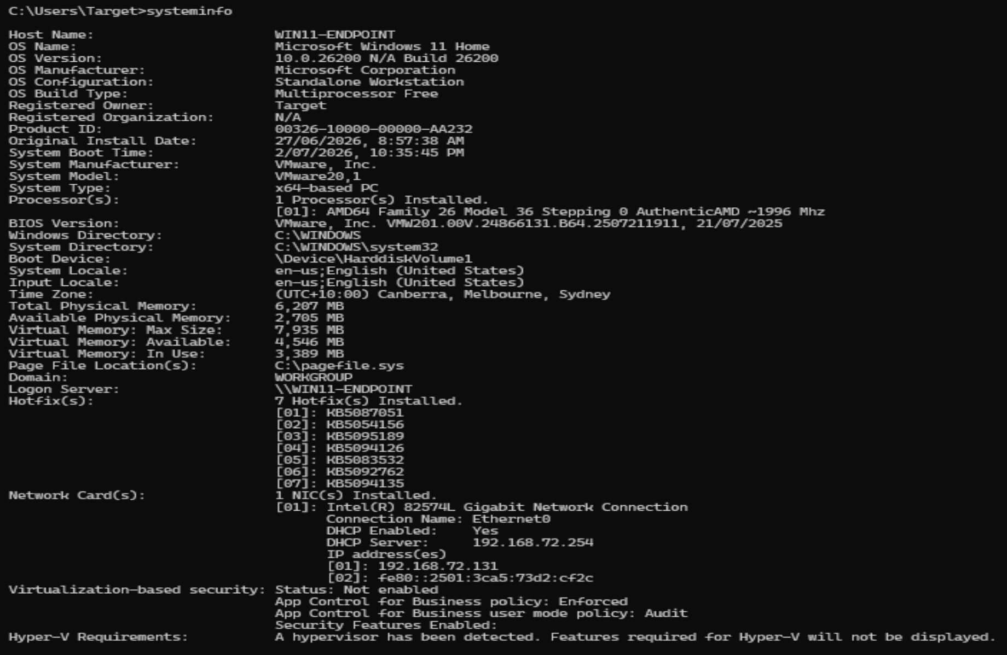
Figure 24: System information discovery, showing Windows 11 Home
An execution technique was then demonstrated with an encoded PowerShell command:
powershell -nop -w hidden -enc dwBoAG8AYQBtAGkA
The window closed automatically after running, which is consistent with the hidden-window flag.
Hunting the discovery commands by process image:
index=* sourcetype="WinEventLog:Microsoft-Windows-Sysmon/Operational" EventCode=1
(Image="*\\whoami.exe" OR Image="*\\net.exe" OR Image="*\\net1.exe"
OR Image="*\\ipconfig.exe" OR Image="*\\systeminfo.exe")
| table _time, User, Image, CommandLine, ParentImage | sort _time
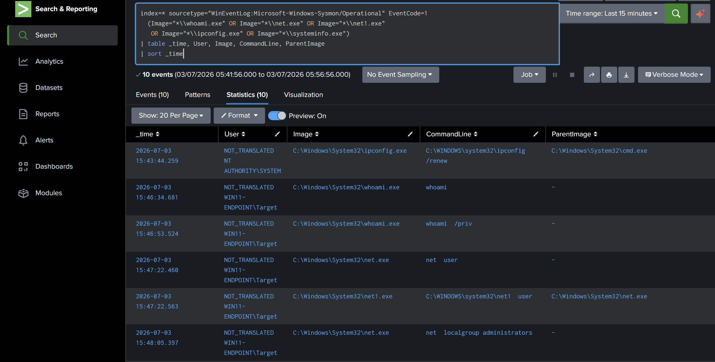
Figure 25: Sysmon process-creation events for the attack sequence
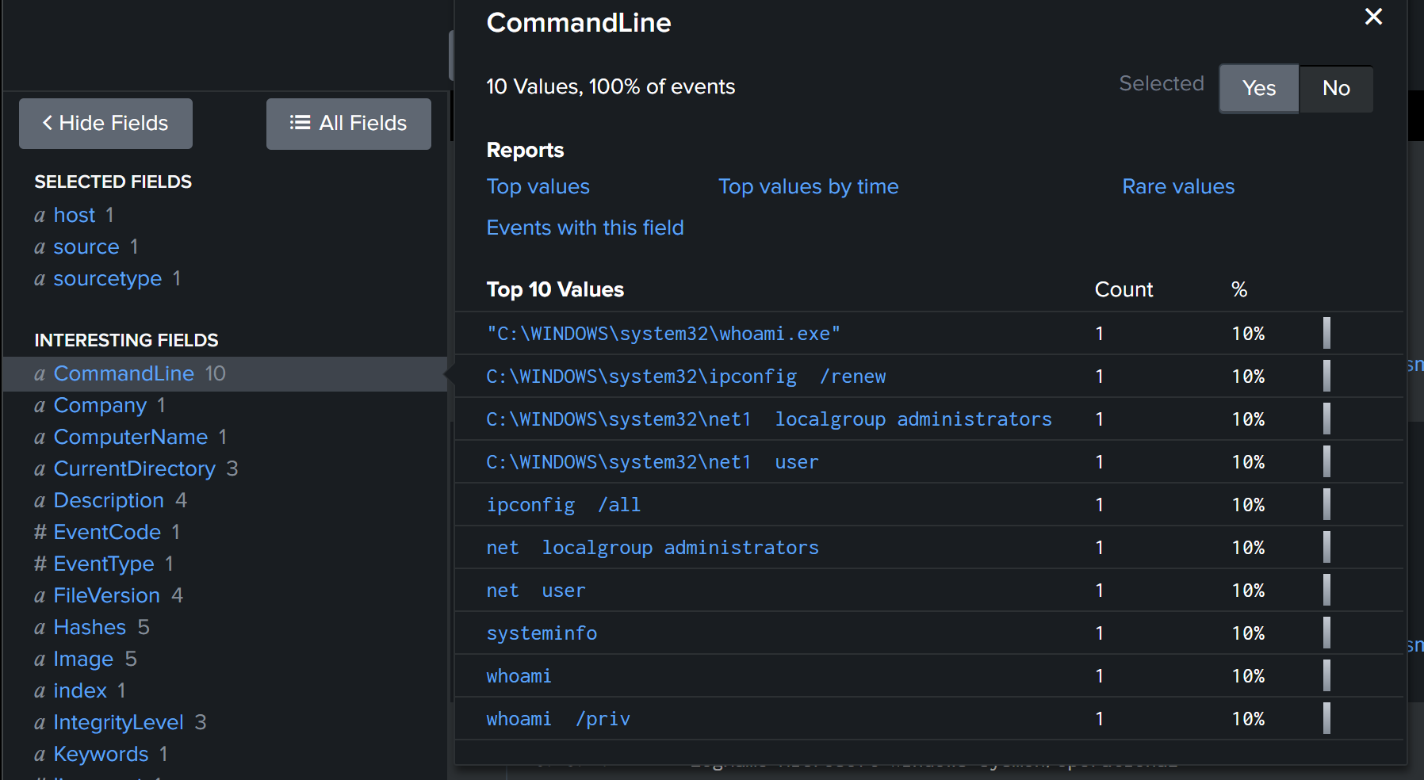
Figure 26: The discovery commands captured with full command lines
Hunting the encoded PowerShell:
index=* sourcetype="WinEventLog:Microsoft-Windows-Sysmon/Operational" EventCode=1 Image="*\\powershell.exe"
(CommandLine="*-enc*" OR CommandLine="*-w hidden*" OR CommandLine="*-EncodedCommand*")
| table _time, User, CommandLine, ParentImage
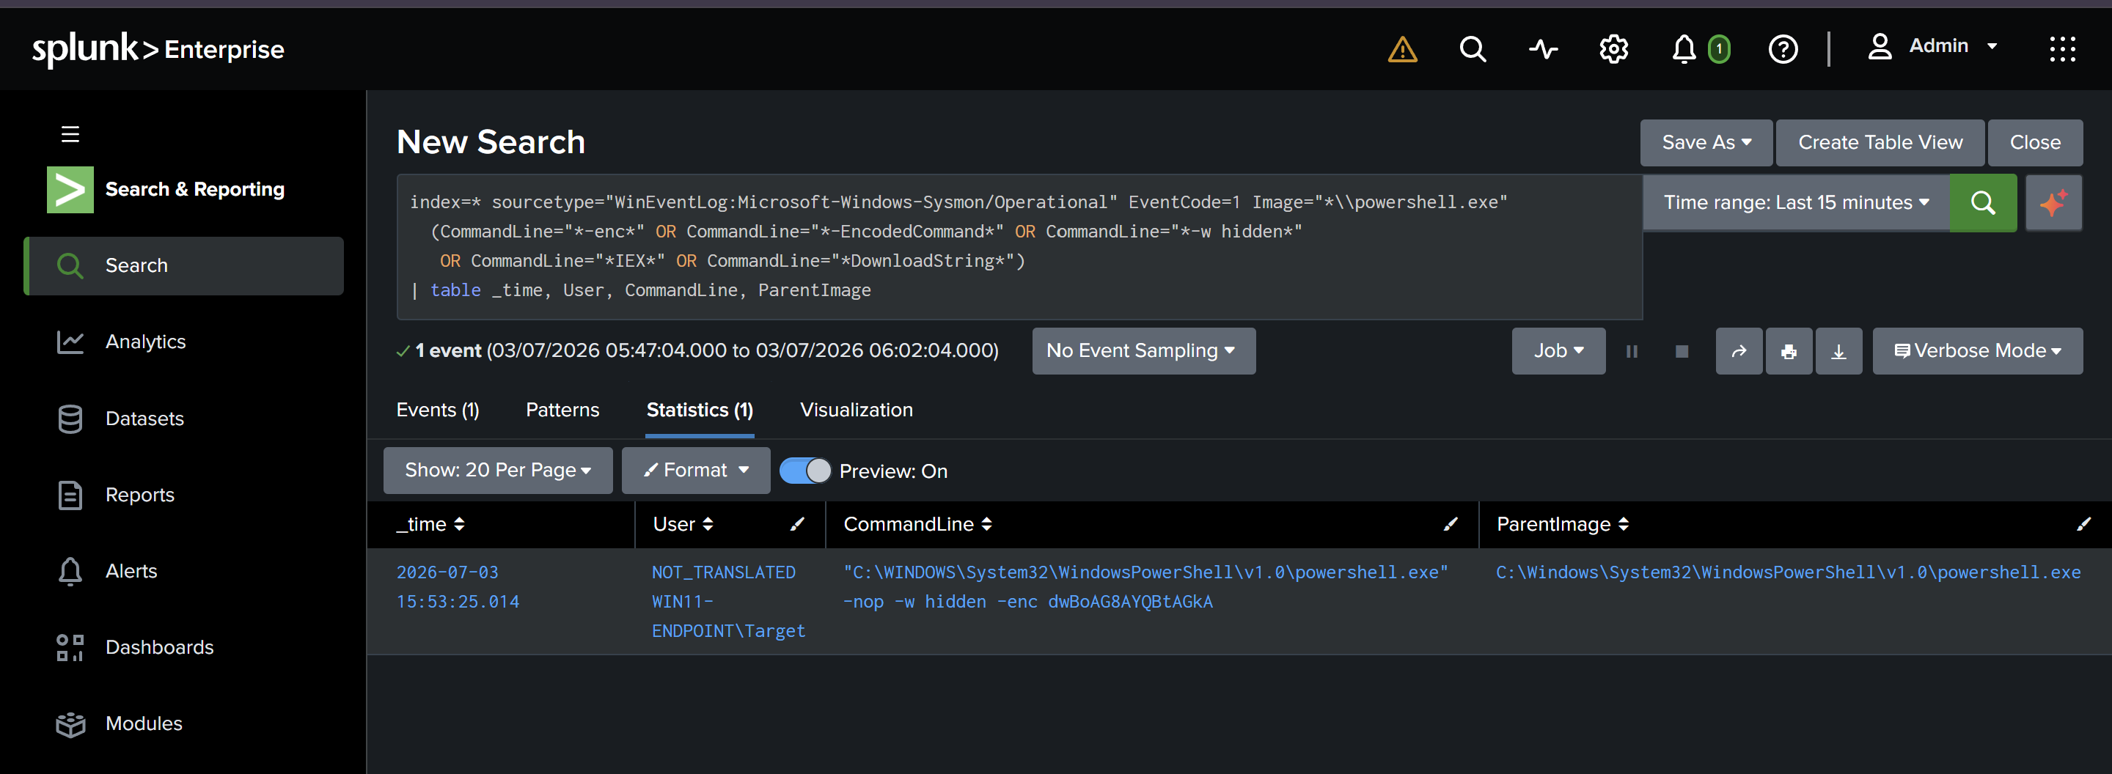
Figure 27: Encoded PowerShell execution detected
The behaviour to call out is the combination of encoding and a hidden window. That pattern is suspicious as behaviour, not as a fixed signature, and reasoning about behaviour rather than static strings is the habit that separates a strong analyst.

7. MITRE ATT&CK mapping
The table below ties each stage of the attack to the data source, the event that surfaced it, and the ATT&CK technique. It is the spine of this project and the source of truth for the detection rules built next.

Stage | Attack action | Event | ATT&CK technique
Recon | Nmap port and service scan | 5156 / 5157 | T1046 Network Service Discovery
Credential access | Brute force via NetExec and hydra | 4625, 4624 | T1110 Brute Force
Access | Valid credentials used over SMB | 4624 | T1078 Valid Accounts
Discovery | whoami /priv | Sysmon 1 | T1033 System Owner/User Discovery
Discovery | net user, net localgroup | Sysmon 1 | T1087 Account Discovery
Discovery | systeminfo | Sysmon 1 | T1082 System Information Discovery
Discovery | ipconfig /all | Sysmon 1 | T1016 System Network Configuration Discovery
Execution | Encoded PowerShell | Sysmon 1 | T1059.001 PowerShell
Execution | Windows command shell usage | Sysmon 1 | T1059.003 Windows Command Shell

8. What broke and what I learned
The troubleshooting is part of the value, not something to hide.
- The RDP brute could not work because Windows 11 Home does not ship an RDP server. SMB was the viable path, and NetExec validated the account credentials.
- Valid credentials are not the same as code execution. The account was not an administrator, so NetExec confirmed the login but could not run code on the host.
- Host telemetry does not catch port scans well. The scan surfaced only in the Windows Filtering Platform events, which reinforces that scan detection belongs on a network sensor.
- The dependable detections all came from Sysmon process creation. Full command-line logging made the discovery and execution stages trivial to hunt, which is a strong argument for prioritising endpoint process telemetry.

9. Next steps
Every row in the ATT&CK table becomes a detection rule in the next project: a Sigma rule repository, version controlled, with each rule converted to Splunk search language and documented.

